**Opening an R script file in Posit (RStudio) Cloud**

1. Download the R script file(e.g., “analyses_in_R.R”), and save the file to somewhere convenient on your computer.
2. Log in to [Posit (RStudio) Cloud](https://posit.cloud/), and open a project by clicking “New Project” (or clicking on your pre-existing project if you created one previously)

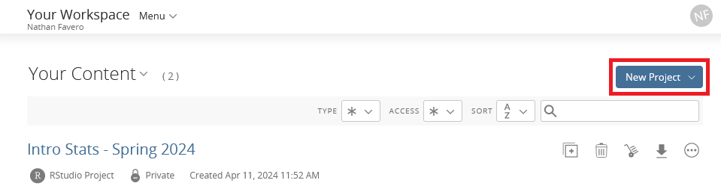

1. In the bottom right, select the “Files” tab and then click the “Upload” button

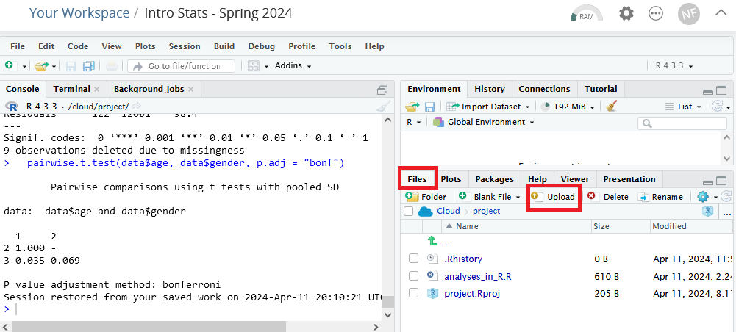

1. Click the “Browse” button under “File to upload:”

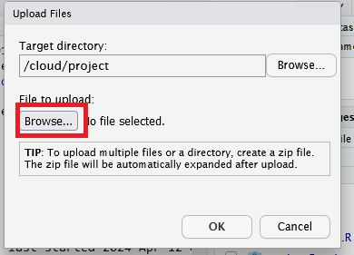

1. Select the “analyses_in_R.R” file that you saved on your computer in Step 1
2. In the top-left, select to open a file

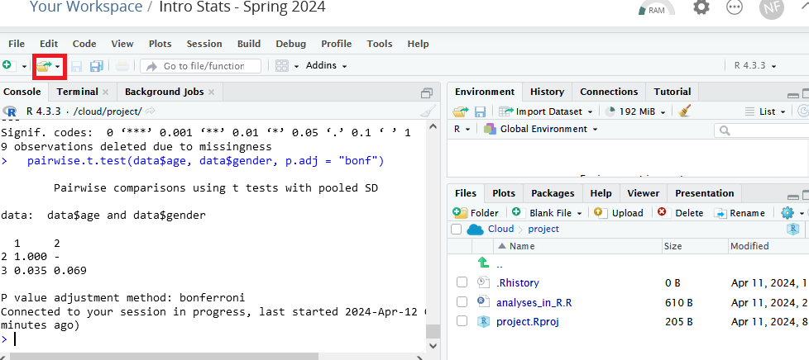

1. Find the “analyses_in_R.R” file and select to open it